**User Port/Parallel Adapter for Commodore 1541/1541-II Rev. 0**

**Testing**

# Test Setup

The tests were conducted with both a Commodore 1541 and a 1541-II and a C64 ASSY 250425 with SpeedDOS 2.7+ Kernal (Figure 1). The 1541 had a SpeedDOS 2.7 installed, the 1541-II required an EPROM (27C128) with SpeedDOS 2.7. Later, the tests were also conducted with a C64 ASSY 250469 (short board) with a SpeedDOS 2.7 Kernal and a 1541 that originally did not have the SpeedDOS Kernal. An EPROM with the original Kernal and SpeedDOS 2.7 (for 1541) was installed on the long board Kernal adapter along with the original 1541 Kernal.

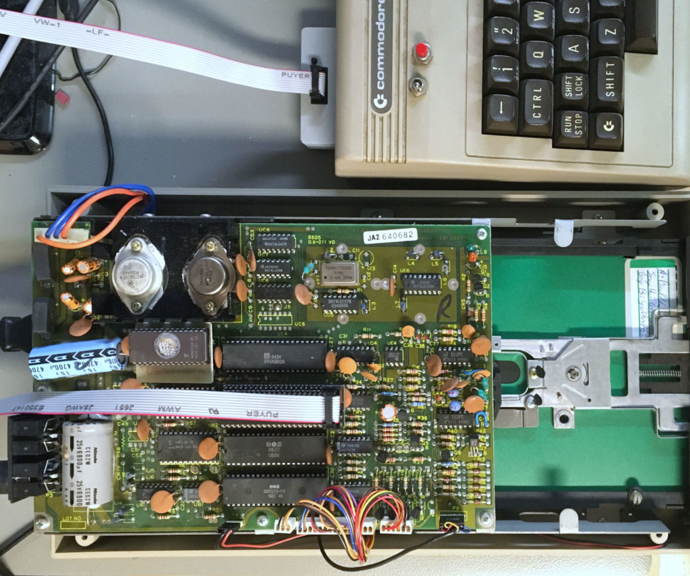

Figure 1: Test Setup

# Test Procedures

The drive was connected via the serial cable, the parallel cable remained unconnected. Both, the drive and the C64 were switched on. The drive could be accessed. The status was reported as “73, SPEEDDOS 2.7 1541,00,00”. The directory of the disk could be displayed properly and the program “Bubble Bobble” was loading properly in 1minute 54 seconds.

The setup was switched off and the parallel cable was connected to the User Port Parallel Adapter, which was connected to the user port.

After switching on the test setup again, the status was reported correctly, the directory was displayed properly and the program “Bubble Bobble” was loading within about 16.8 seconds.

Clearly, the parallel transmission has reduced the loading time of “Bubble Bobble” to 15%.

Several programs were loaded successfully with the SpeedDOS parallel setup.

A 2nd 1541 drive was equipped with a SpeedDOS-Kernal and the parallel cable (Figure 2). The drive was connected to an ASSY 250469 short board. The previous tests were conducted successfully with the new setup.

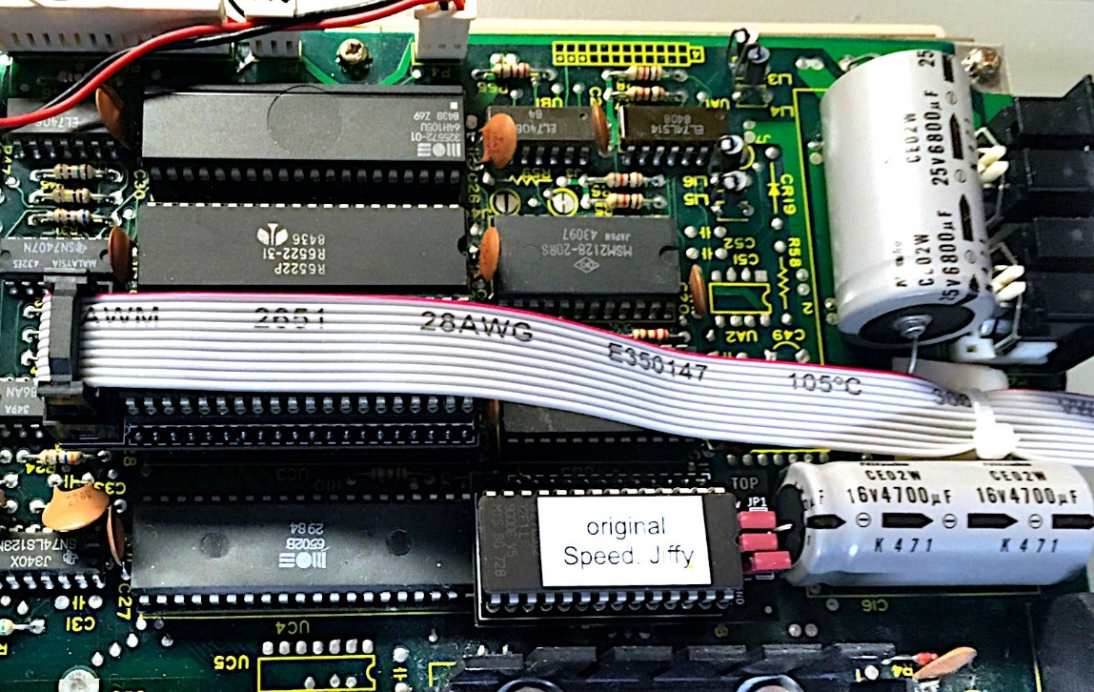

Figure 2: VIA adapter and a SpeedDOS EPROM (on adapter board)

After the low-profile VIA Parallel Adapter was finally working, the tests were conducted with a 1541-II drive (Figure 3) and the ASSY250425 C64.

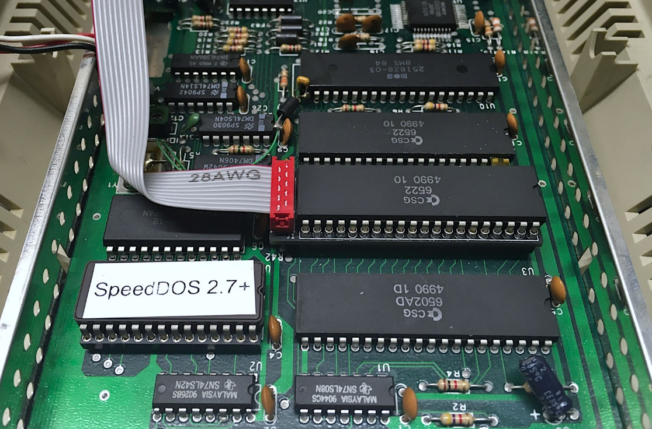

Figure : SpeedDOS Setup in a 1541-II

# Conclusion

The User Port Parallel adaptor in conjunction with both VIA Parallel adaptors are fully functional.